ASSIGNMENT

1.Create a blog or website using Blogspot . Customize the theme design and post new article with 500 words.

LINK: [Blogspot](https://trendingdessert.blogspot.com/2023/09/sweet-chronicles-exploring-irresistible.html%23more)

2. Create a New Facebook Business Page and post one

social media poster for your brand.

LINK: [Facebook](https://www.facebook.com/bigbitesrestarant?mibextid=ZbWKwL)

3. Create and design a social media advertisement poster

using canva.

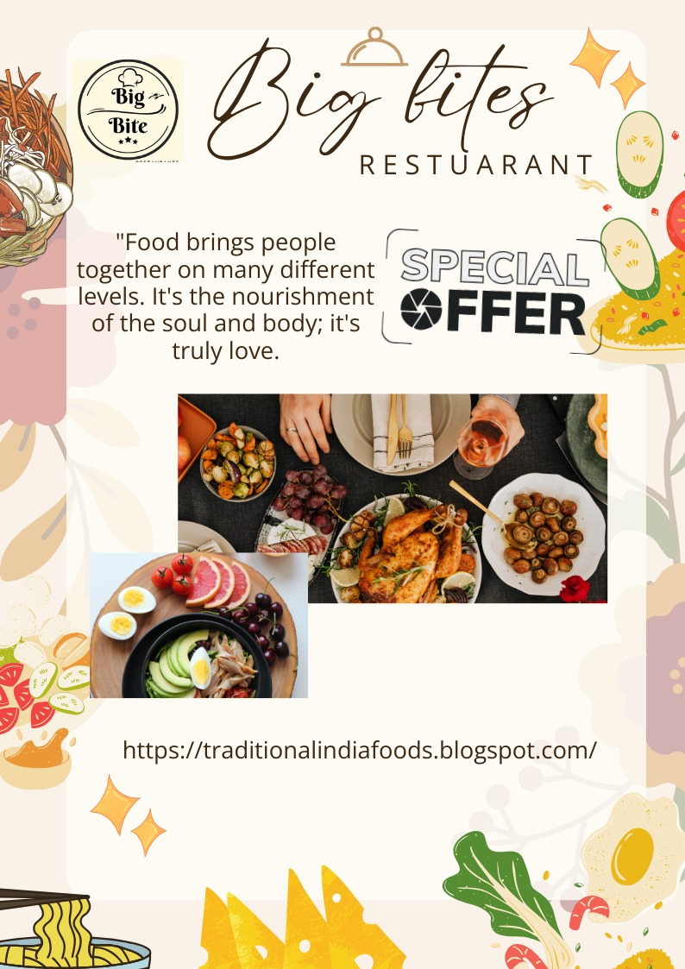

4. Create email newsletter design using MailChimp or canva

tool.

